**Lesson 1**

|  |  |
| --- | --- |
| Conscientiousness | * Tendency to be dutiful * Seeks competency and achievement |
| Agreeableness | * Tendency to give in and seek social   harmony |
| Neuroticism | * Tendency to easily experience unpleasant emotions |
| Openness to Experience | * Fascination with novelty (new, original, or unusual) * Tendency to enjoy diversity |
| Extroversion | * Tendency to seek stimulation and engage with   external world   * **Extroversion** is defined as the quality of being outgoing and directing attention to things other than yourself. |

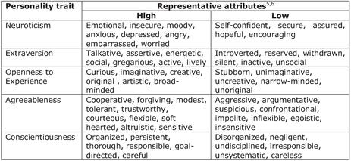

* Research shows that **high Conscientiousness** and **low Neuroticism** equals to better individual performance across most jobs

Other dimensions could also affect job performance:

Agreeableness

•High → interpersonal aspects (e.g. getting along with others)

•Low → situations that require tough and objective decisions

Extroversion

•High → specific occupations (e.g. salespeople, managers, police officers)

Openness to Experience

•High → jobs in creative industry and where adaptability is needed

•Low → conventional and down-to-earth jobs such as police work, some service-related jobs

Lesson 2

Self-esteem - extent to which you respect, like and are satisfied with yourself

Self-efficacy - belief about chances of successfully accomplishing a specific task

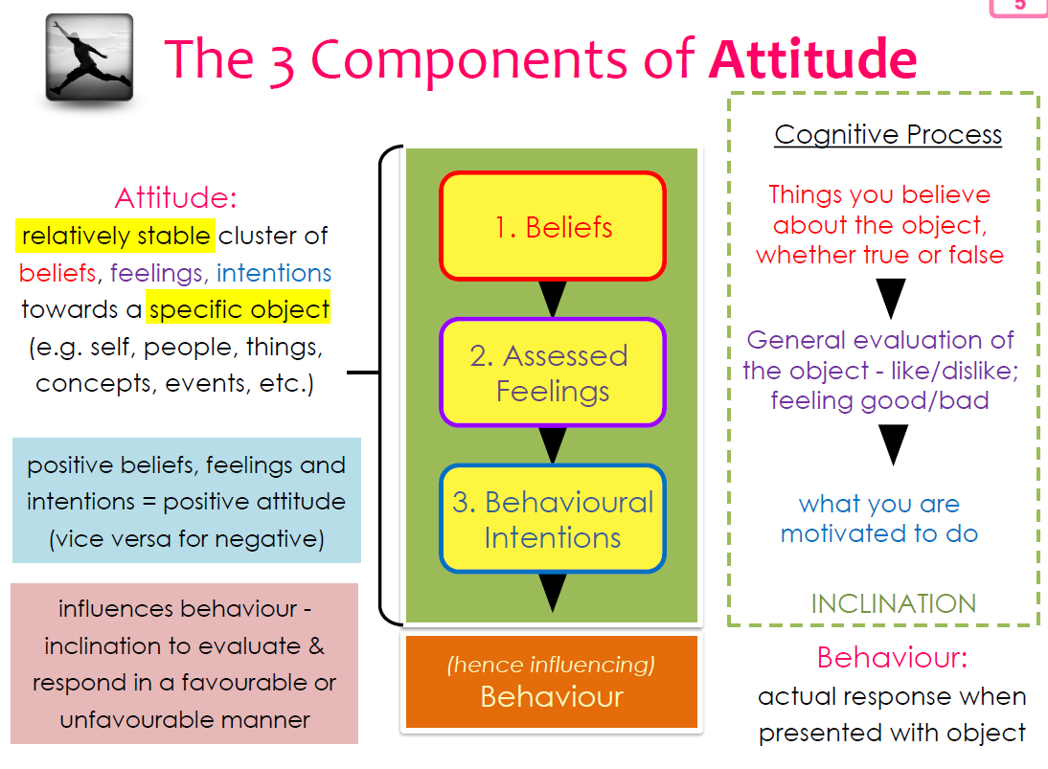

Improving Self efficacy

Prior Experience

* Assign easier work first and then gradually more complex work. This creates a series of successes for the candidate.
* Coach the candidate in the creative brainstorming process so that he can succeed with his hard work

Behaviour Models

* Ask to partner and work with someone in similar position in the department. This will allow the candidate to learn from him/her on how to analyse and develop creative ideas.

Persuasion from Others

* Even if the candidate’s ideas are not very creative, look for elements worth praising and acknowledge them in meetings.
* Highlight Ken’s strengths and how he can utilise them to contribute usefully.

Assessment of Physical/Emotional State

* Tell the candidate to see frustration as part of the process. If they are not frustrated, they are not pushing yourself.
* Share some stress management techniques with Ken.

Lesson 3

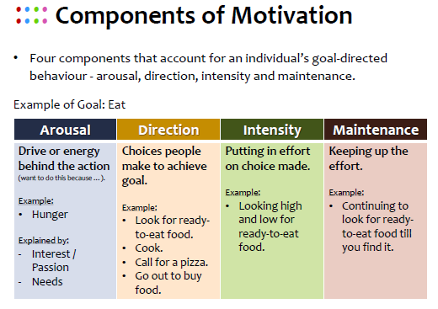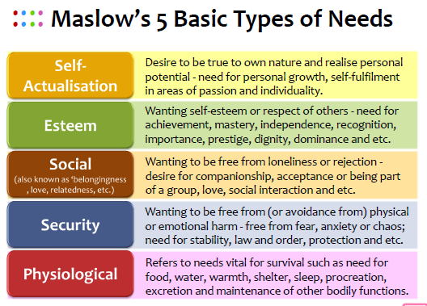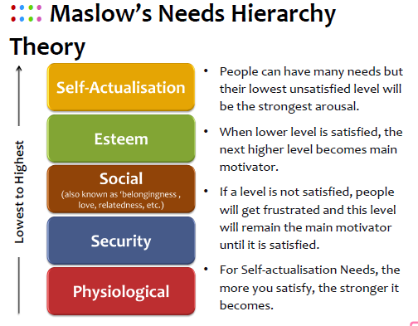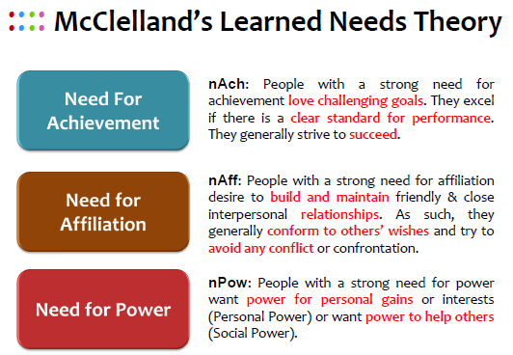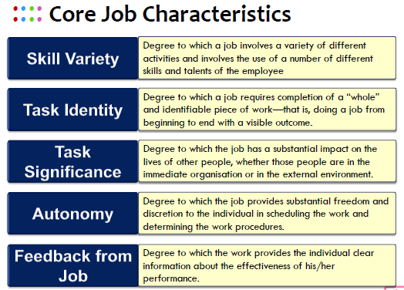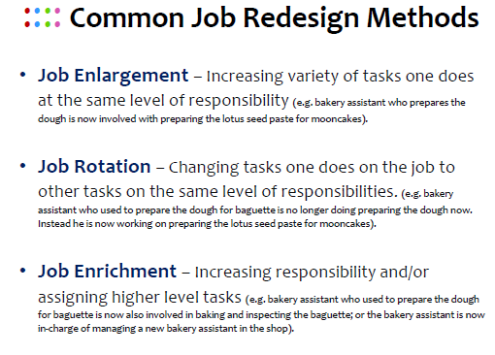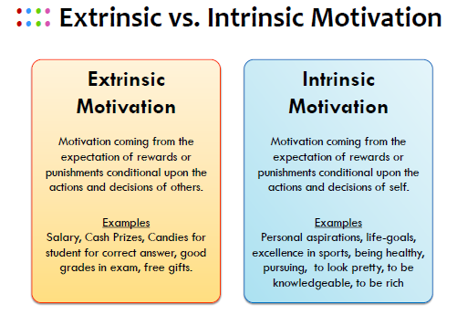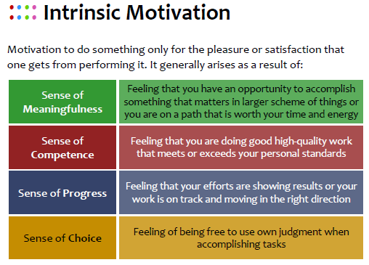

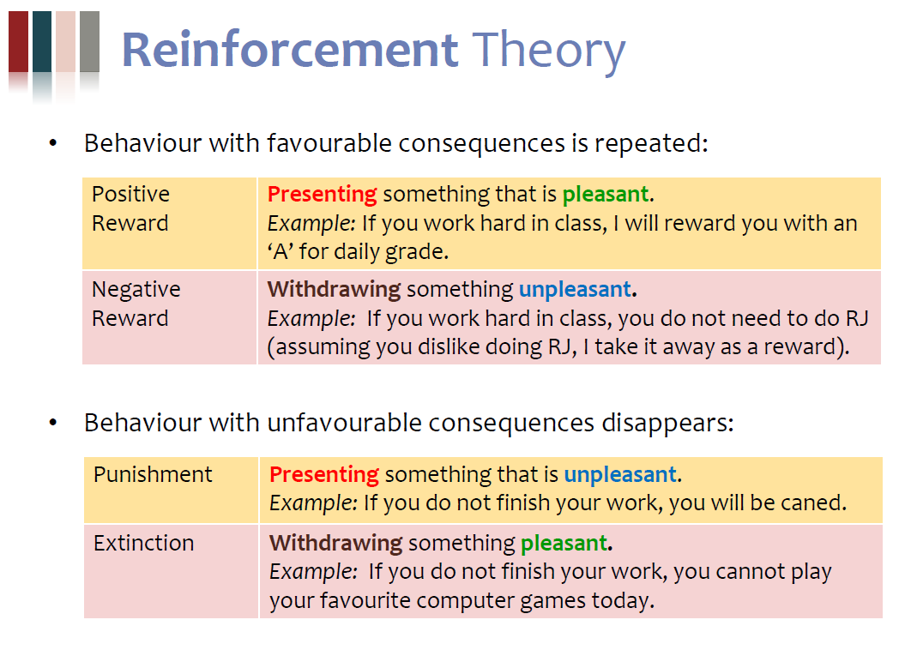

Lesson 4

Vroom’s Expectancy Theory



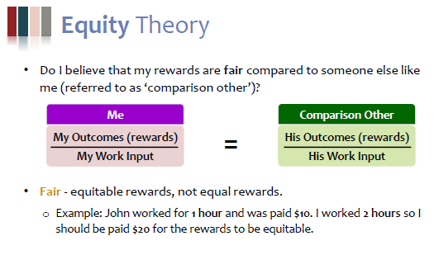

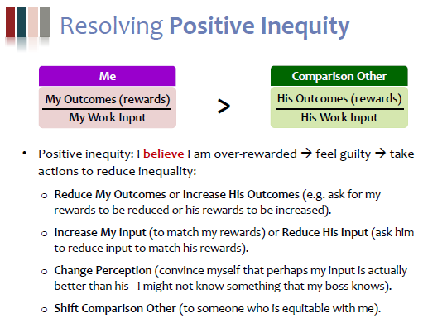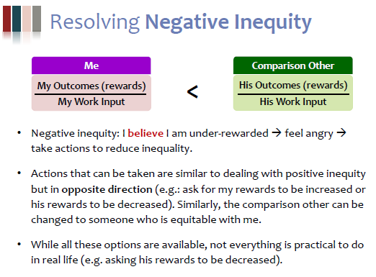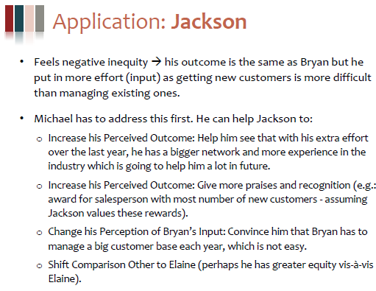

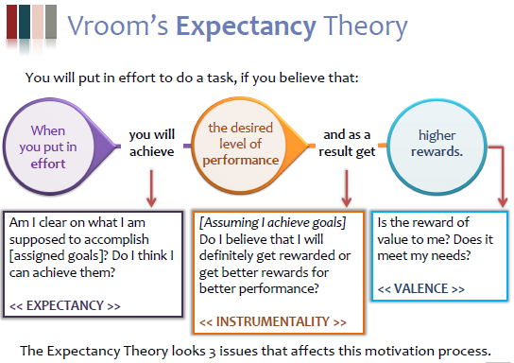

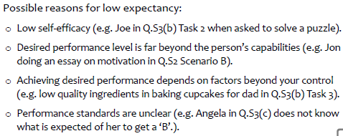

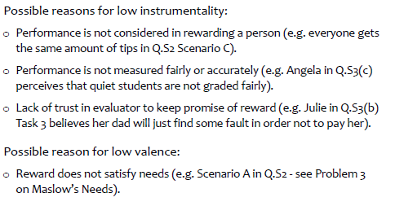

Solutions:

Low Expectancy

* Provide training to increase the candidate’s capability (e.g. making sales pitch).
* Provide simpler tasks which are easier to perform (prior experience).
* Assign the candidate to someone one with more experience to learn from them (behaviour models).
* Highlight the candidate’s strengths and how they can use it to their advantage

Low Instrumentality

* Identify the candidate’s needs and cater rewards accordingly.
* Share performance criteria for promotion (assuming they are achievable for the candidate + meeting criteria is a guarantee of promotion).
* Create rewards directly linked to their contribution and work

Low Valence

* If the candidate has proven themselves, provide opportunities for the candidate to realise his full potential possibly through:

- asking him to manage more challenging customers.

- assigning him to mentor junior salespersons like Elaine.

- changing or widening his job scope (e.g. heading a new division)

* Additional Bonuses, Increase in pay

Lesson 5

**FEELING VOCABULARY**

|  |  |  |  |
| --- | --- | --- | --- |
| **Angry**  aggravated  annoyed  defiant  disgusted  enraged  exasperated  frustrated  furious  hateful  hostile  indignant  infuriated  mad  obstinate  outraged  perturbed  peeved  pissed off  rebellious  seething  spiteful  surly  upset  vengeful  **Surprised**  aghast  amazed  astonished  astounded  incredulous  shocked  startled  **Thankful**  appreciative  grateful  gratified  indebted  obliged  relieved  **Uncertain**  cynical  doubtful  dubious  distrustful  hesitant  indecisive  pessimistic  skeptical  suspicious  unsure  unsettled  **Worried**  agitated  anxious  bothered  restless  tense  uneasy  unsettled | **Ashamed**  apologetic  embarrassed  foolish  guilty  humble  idiotic  mortified  regretful  remorseful  shameful  worthless  **Confident**  bold  capable  centered  eager  energetic  focused  grounded  hopeful  inspired  keen  optimistic  powerful  productive  strong  sure  trusting  **Thoughtful**  challenged  curious  illuminated  informed  interested  pensive  reflective  **Wanting**  empty  envious  homesick  hungry  ignored  jealous  lonely  longing  lustful | **Confused**  baffled  befuddled  bewildered  disoriented  flustered  perplexed  puzzled  scattered  troubled  unfocused  **Happy**  amused  cheerful  delighted  ecstatic  elated  excited  exuberant  gleeful  high  joyful  mischievous  **Hurt**  abandoned  abused  attacked  belittled  bitter  cheated  disappointed  dismayed  grieving  gypped  humiliated  mournful  sorrowful  rejected  resentful  **Weak**  inadequate  burdened  controlled  despairing  discouraged  helpless  hopeless  impotent  inhibited  lost  passive  powerless  restricted  suicidal | **Loving**  affectionate  aroused  caring  devoted  intimate  tender  warm  **Sad**  despondent  depressed  dismal  low  melancholy  miserable  unhappy  weepy  **Satisfied**  adequate  content  mellow  peaceful  pleased  **Scared**  afraid  alarmed  fearful  frightened  horrified  hysterical  insecure  intimidated  nervous  panicky  petrified  terrified  threatened  vulnerable  **Uncaring**  ambivalent  apathetic  bored  busy  detached  exhausted  indifferent  lethargic  lazy  tired  unmotivated  nonchalant  occupied  selfish  unconcerned |

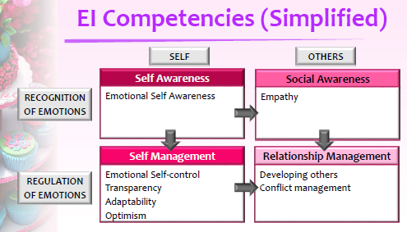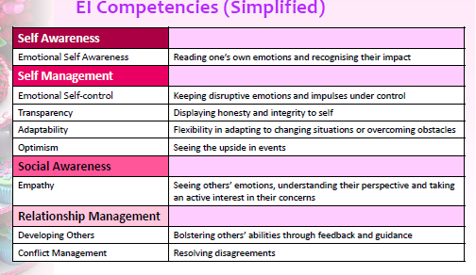

Strategies

|  |
| --- |
| Emotional Self-Awareness   * Take time off work to reflect on how the candidate feels regarding current work environment (anger, fear, frustration & anxiety). * Help identify ***situations*** which trigger these emotions (i.e. when & why he feels this way) and List how he tends to behave in these situations and how other people behave |
| Emotional Self-Control   * Tell the candidate to recognise symptoms of emotions (e.g. feeling flushed, sweaty palms, headache, faster heartbeat) and take himself out of the situation (e.g. taking a break before dealing with situation). * Tell the candidate to identify at least 3 ways to respond to a situation, think about consequences of each and then choose best way to respond. * Allow the candidate to delay making decisions / communicating with staff, to first think clearly and choose the best response to a situation |
| Transparency   * Talk to Higher Management on what can be realistically done to the current situation and people * Share with staff the rationale for changes as well as why this is very important to him * Share with other what is not acceptable to him (e.g. what he would consider slow or unmotivated behaviour) |
| Adaptability   * Reflect on differences and why using certain strategies might not work. * Identify what are his ‘must-haves’ for the staff (e.g. coming in at 2am) and can be flexible with (e.g. going on leave). * Helps to avoid anger / frustration in pushing through changes that might not work |
| Optimism   * Reflect on successes * See resistance as opportunity to get to know them |
| Empathy   * Practise active listening and attending techniques. * Imagine the situation from other person’s perspective before approaching them -How much information/resources do they have compared to you; what might be pressures on them that might not be pressures on you, etc. |
| Developing Others:   * Use proper techniques to provide feedback * Coach them on what he expects from them. – This reduces conflicts over work expectation or staff not being |
| Conflict Management   * Seek to first understand the perspective of others (e.g. why they need to go on leave) Empathy. * Look for what you can be flexible about and give in to staff in return for their commitment Adaptability * Be clear about what are important to you and your expectations of others Transparency |

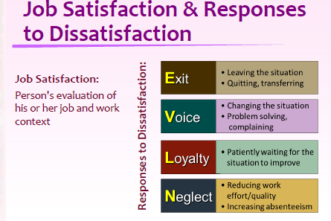

**Lesson 6**

Common Perceptual Errors

1. Stereotype

The process of assigning traits to people based on their membership in a social category.

2. Halo Effect

The extension of one particular positive trait to influence the total judgment of that person.

3. Horn Effect

The extension of one particular negative trait to influence the total judgment of that person.

4. Recency Effect

A perceptual error in which the most recent information dominates one's perception of others.

5. Primacy Effect

Our tendency to quickly form an opinion of people based on the first information we receive about them.

6. Similar-to-me Effect

The perceiver tends to give more favourable evaluations to people who are similar to themselves in terms of background or attitudes.

7. Self-serving Bias

A perceptual error whereby people tend to attribute their favourable outcomes to internal factors and their failures to external factors.

8. Fundamental Attribution Error

The tendency to see the person rather than the situation as the main cause of that person’s behaviour.

9. Contrast Error

Perception of performance exaggerated as a result of conscious/subconscious comparison with another person.

**Lesson 7**

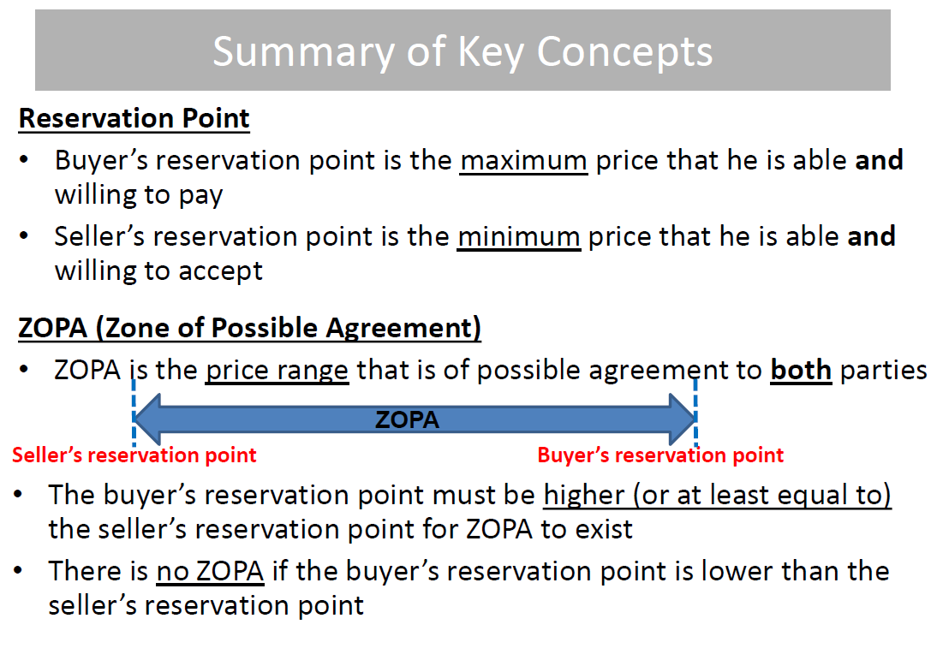

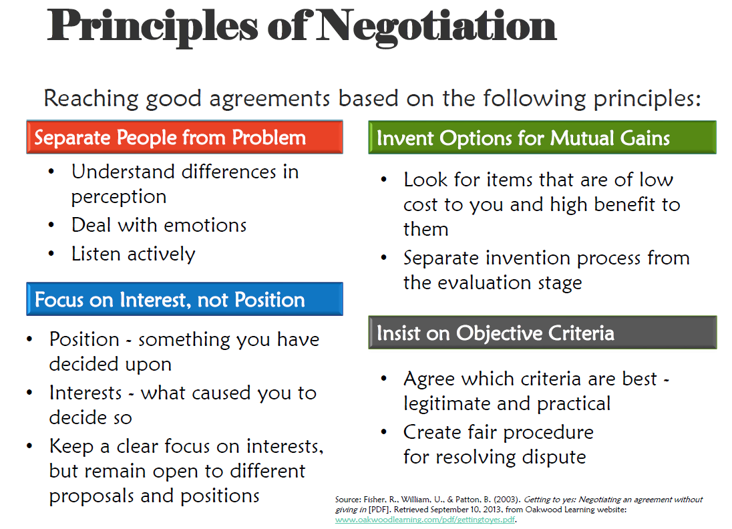

**Lesson 8**

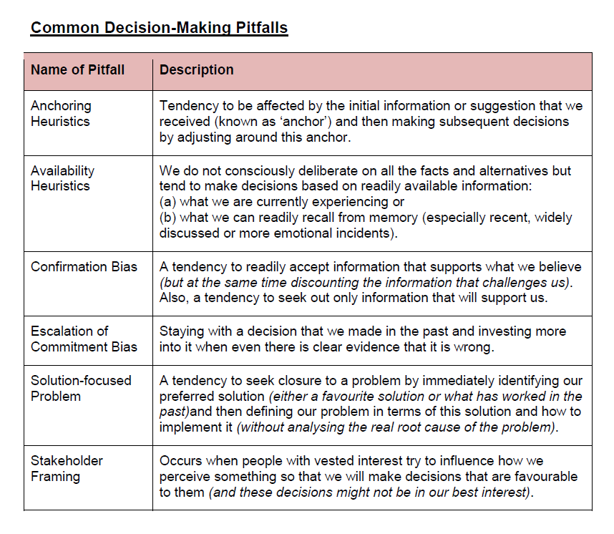

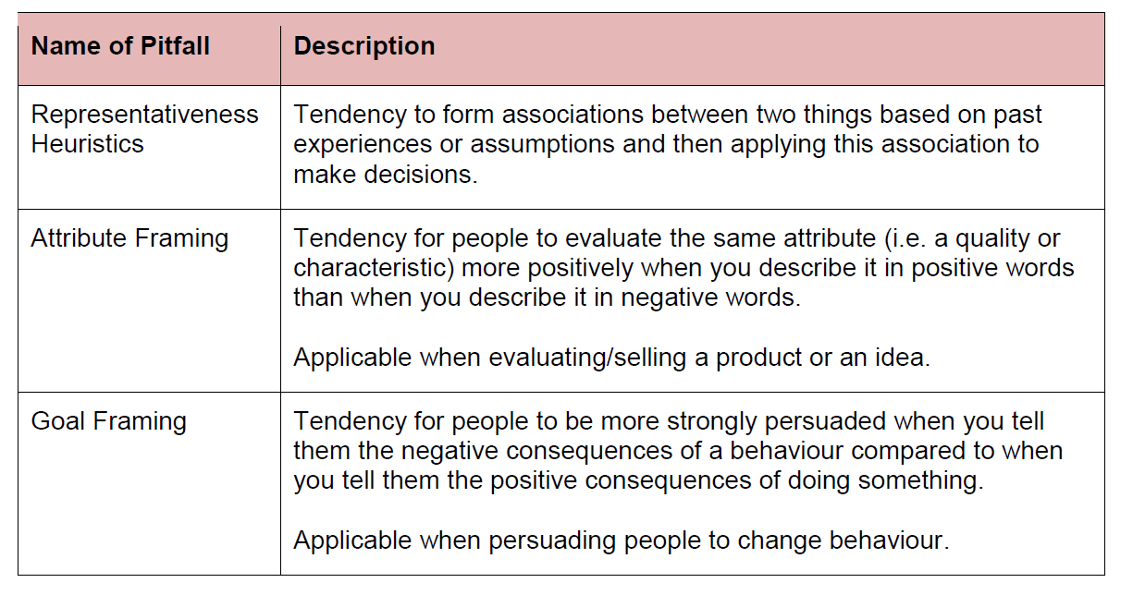

*Lesson9*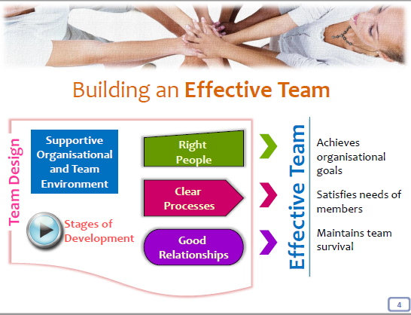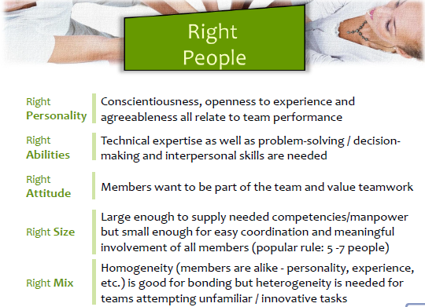

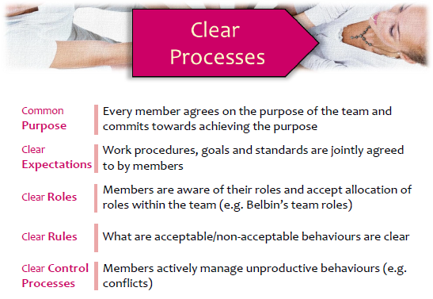

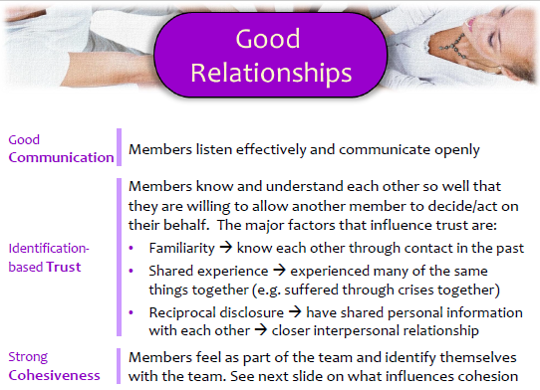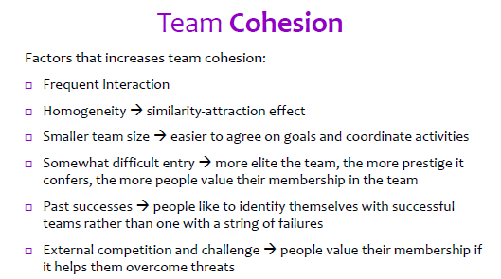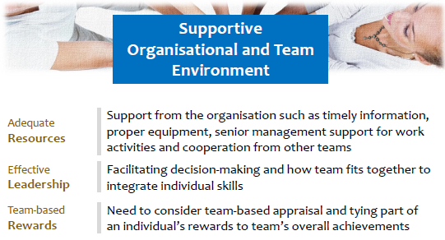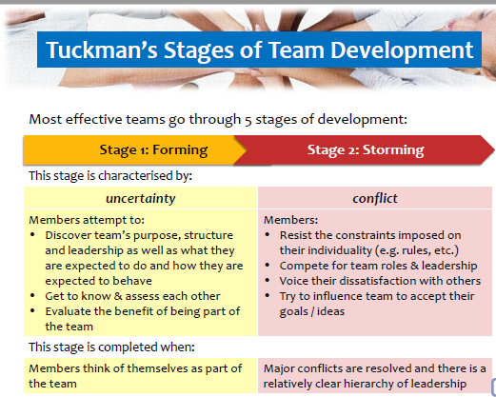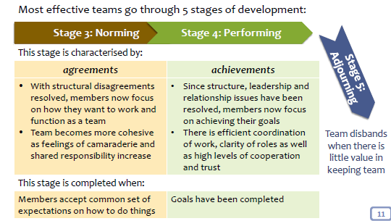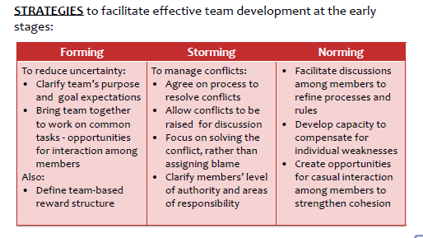

Lesson 10

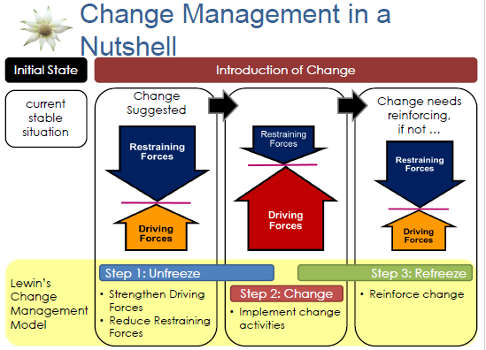

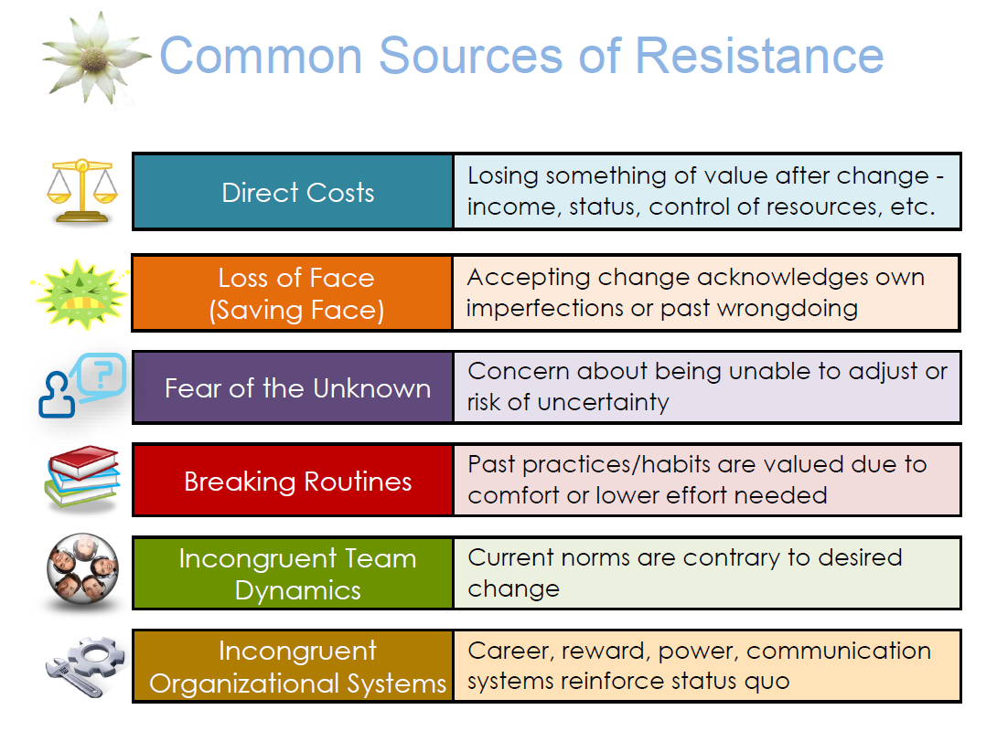

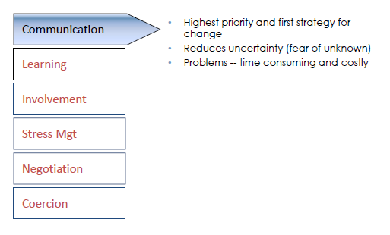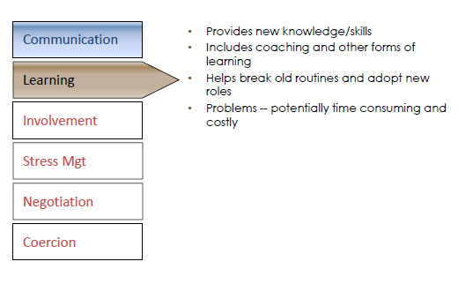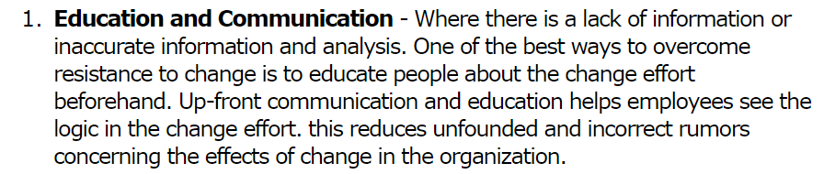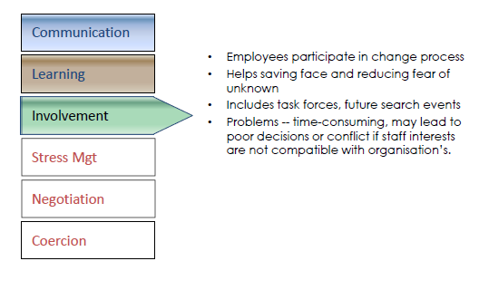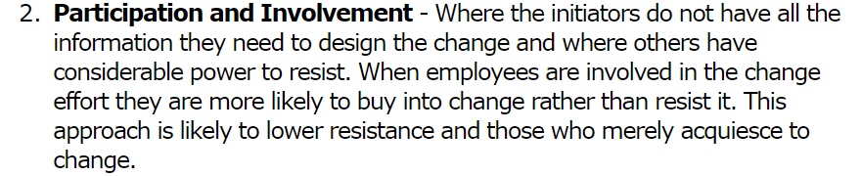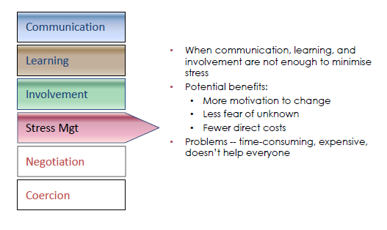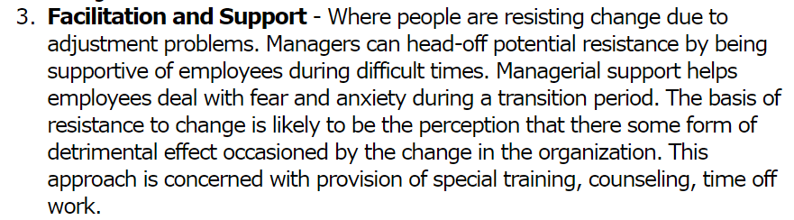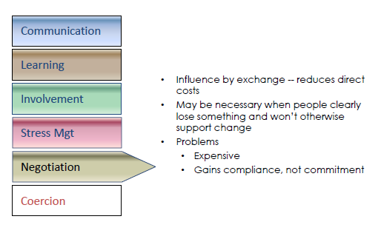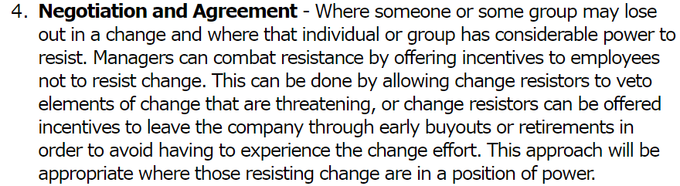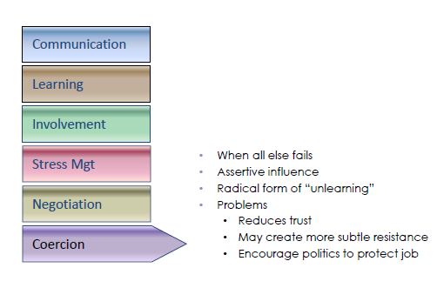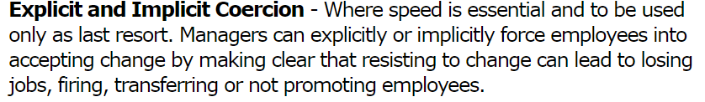

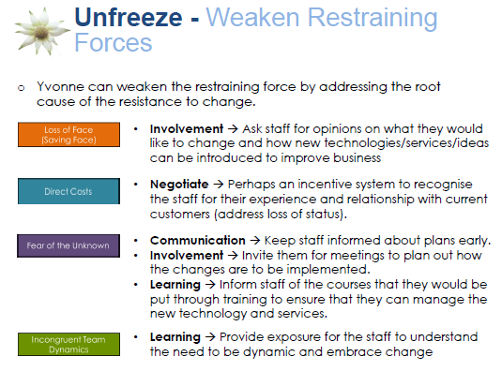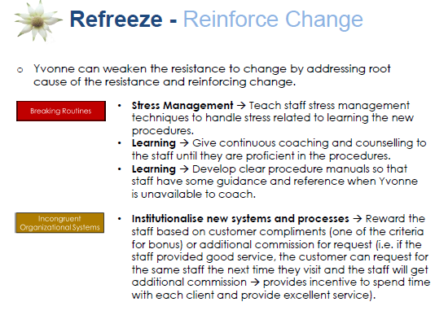

Lesson 11

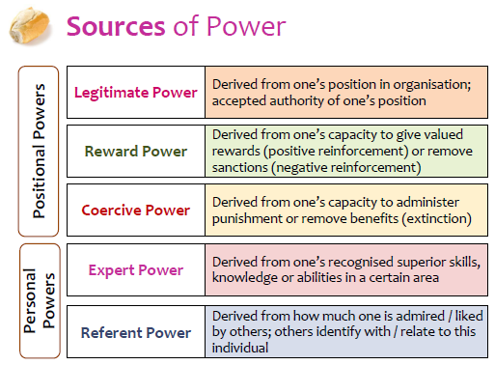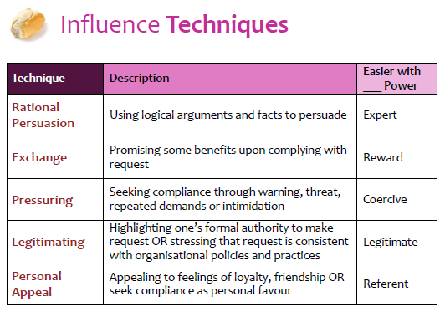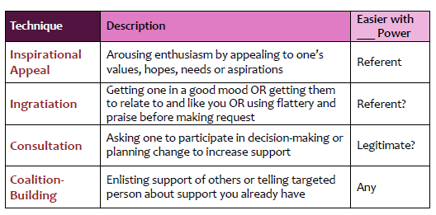

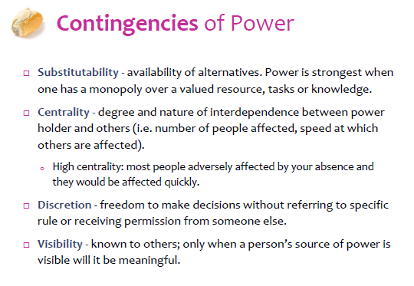

Lesson 12

